

**INFORMATION**

by

Marcel Hacker

|  |  |
| --- | --- |
| Wien, 2024 / Vienna, 2024 |  |
|  |  |

Table of Contents

Project structure 3

System calibration 4

VICON motion capture 4

Surface-EMG 4

Markerset 5

Lower body 5

Lower foot (12 markers per leg) 5

Upper foot (4 markers per side) 6

Pelvis (2 markers) 7

Upper body 8

Sacrum, Spine (T10, C7) & Acromion (7 markers) 8

Arms 9

Upper arms (10 markers per side) 9

Hands (3 markers per side) 10

Head 10

Skull (3 markers) 10

Measurement process 11

Attempts 11

# Project structure

/athlete_X

- athlete_X_scaled.osim  
- static_00.c3d  
- static_00.trc  
- static_01.c3d (Backup static)  
/ conv_emptybar_0  
/ conv_emptybar_1  
/ conv_emptybar_2  
/ conv_dl_0  
/ conv_dl_1  
/ conv_dl_2  
/ sumo_emptybar_0  
/ sumo_emptybar_1  
/ sumo_emptybar_2  
/ sumo_dl_0  
/ sumo_dl_1  
/ sumo_dl_2  
/ sq_emptybar_0  
/ sq_emptybar_1  
/ sq_emptybar_2

/ are folders  
- are files

# System calibration

### VICON motion capture

1.Turn on the cameras and the VICON PC.

2.Setup cameras in the direction of desired motion.

3.Open VICON 2.16.

4.Use reoriented setup in VICON.

5.Turn on force plates.

6.Control forces on them, by laying weight plates on them.

7.Mask the cameras and set the origin

8.Place the wood plates on them and zero the forces.

9.Remask the cameras and set the origin.

Note: Check if force plates have the right direction and make sure they are displaying the correct weight on them.

### Surface-EMG

1.Turn on the EMG-system.

2.Use EMGs with full battery.

3.Cut hair on EMG positions.

4.Desinfect the positions.

5.Place the electrodes very close each other (standardised distance between them).

6.Check channels and signals in the VICON program.

7.Write down channel number and representing muscle.

# Markerset

Markerset: Rajapogal

Markers count: 63 markers

## Lower body

### Lower foot (12 markers per leg)

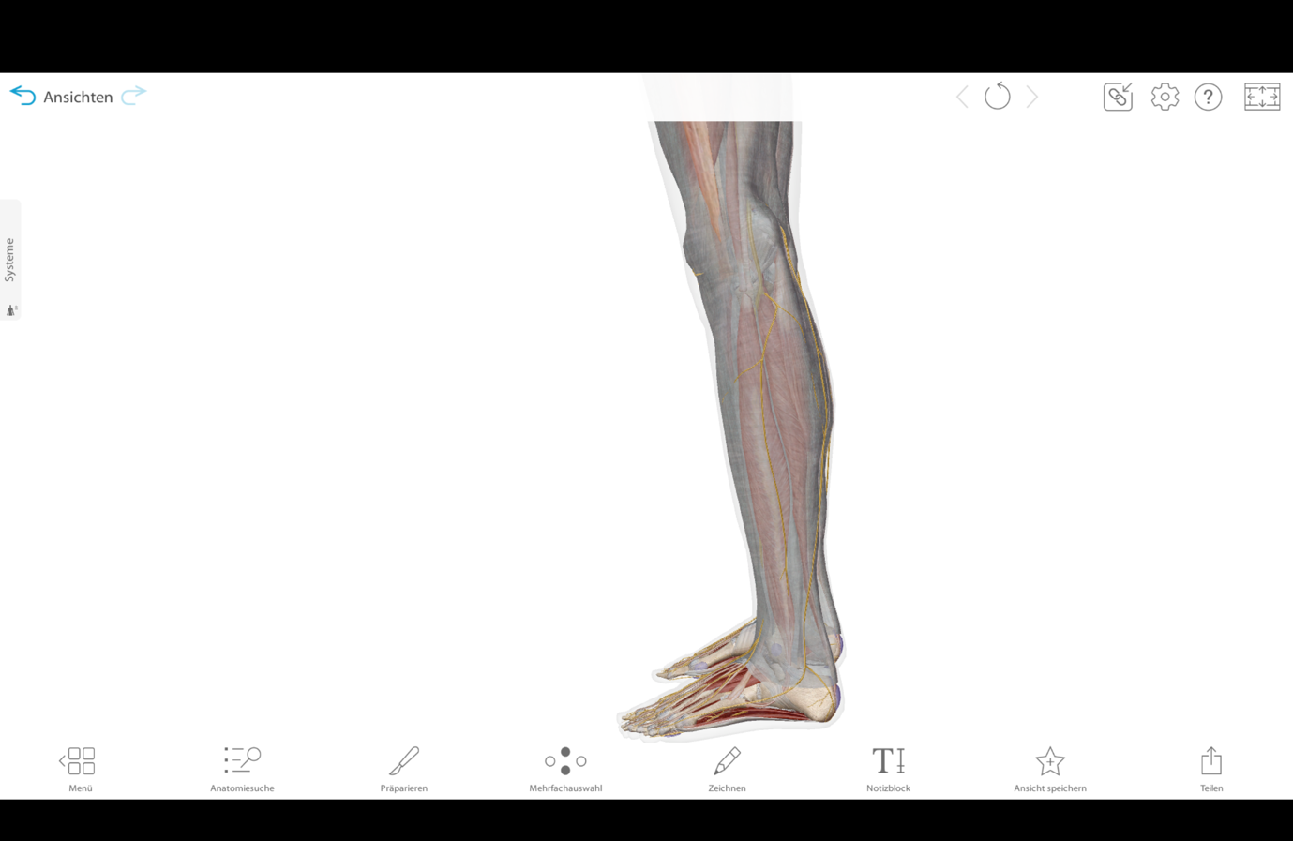

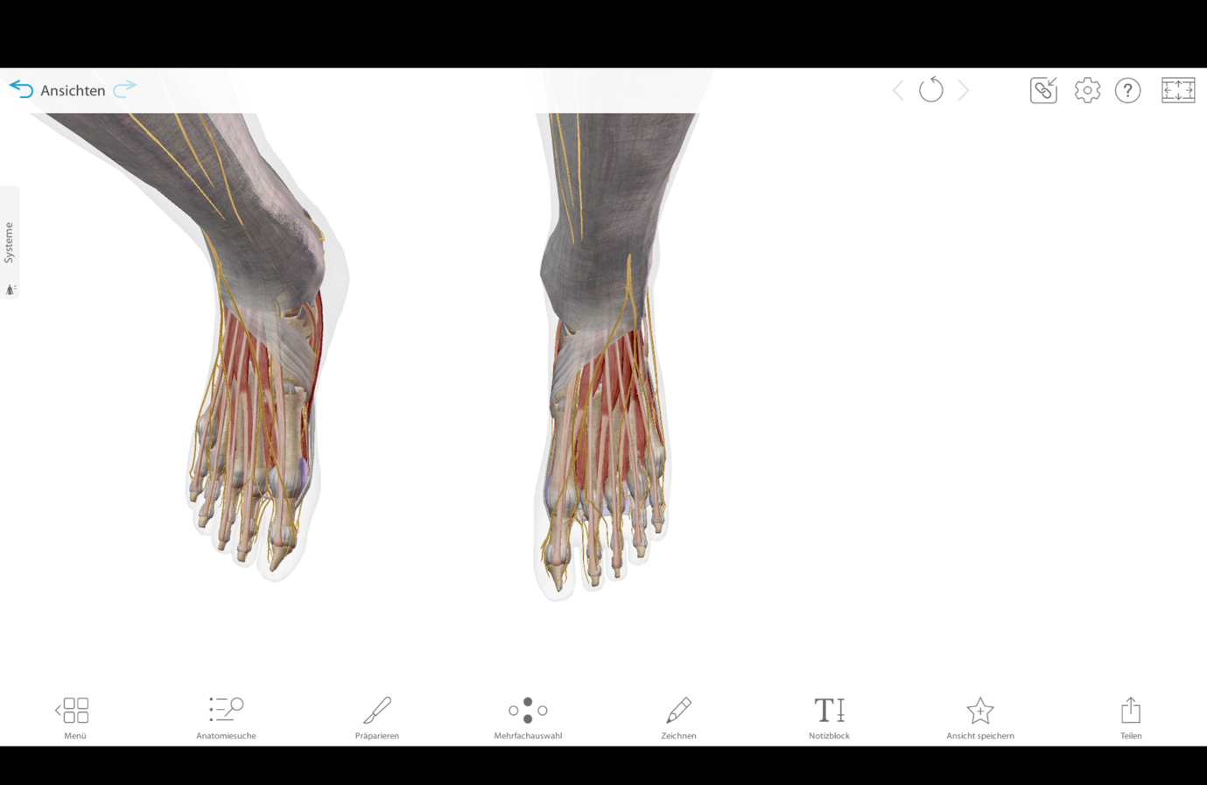

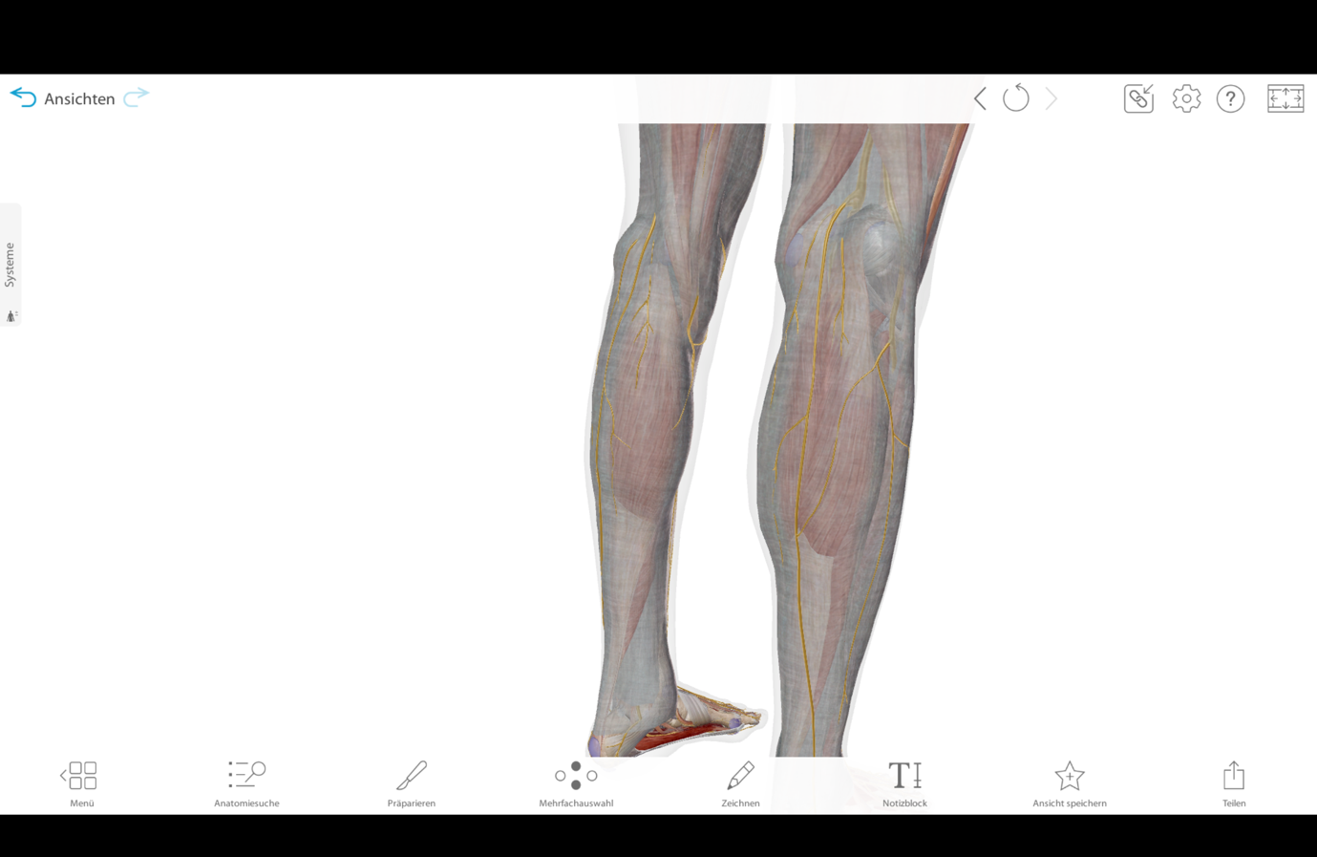

### Upper foot (4 markers per side)

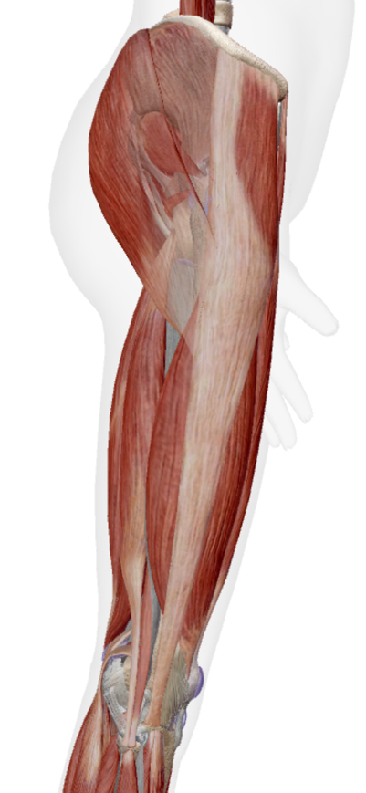

### Pelvis (2 markers)

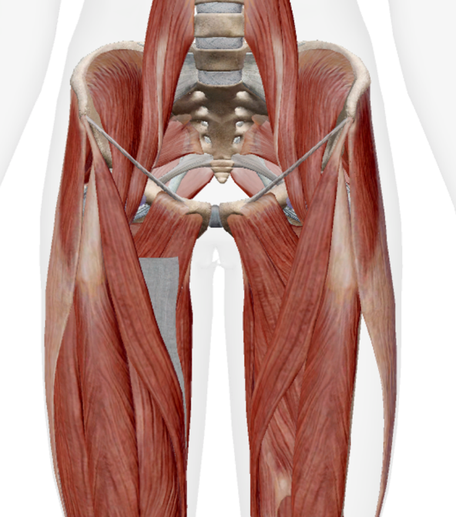

## Upper body

### Sacrum, Spine (T10, C7) & Acromion (7 markers)

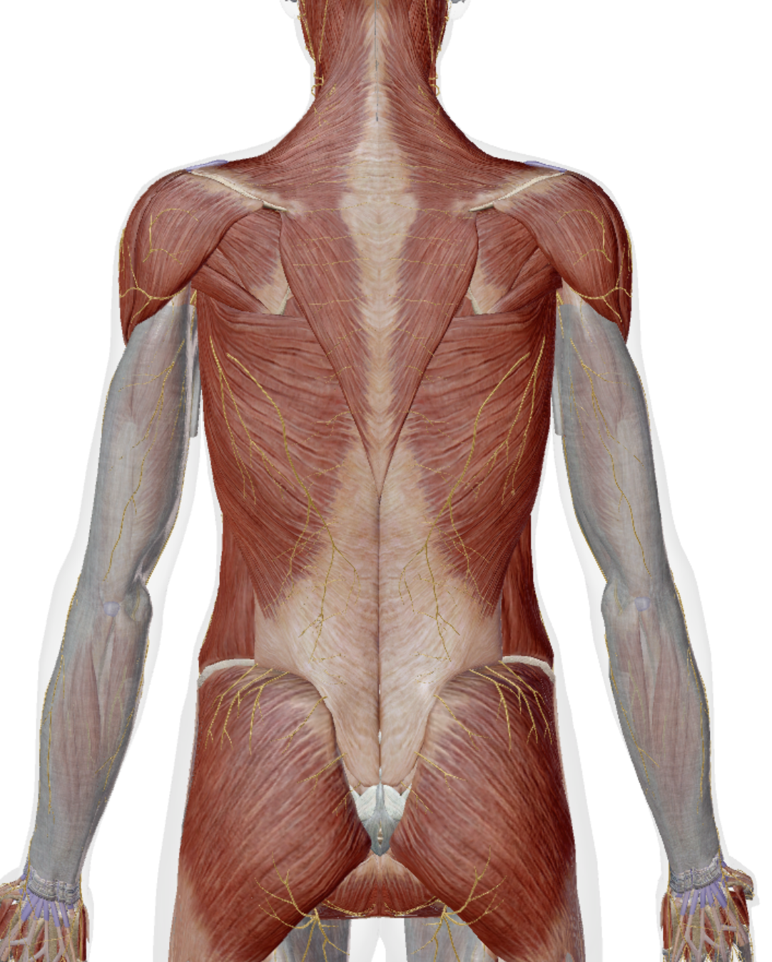

## Arms

### Upper arms (10 markers per side)

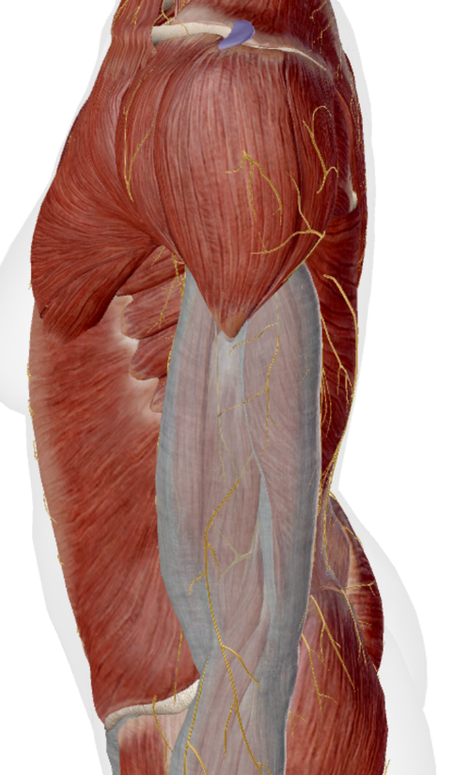

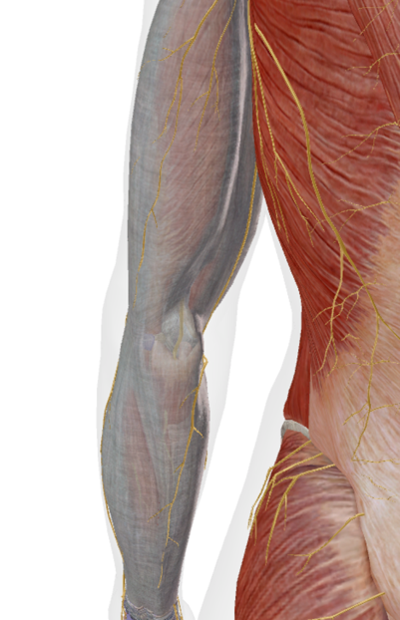

### Hands (3 markers per side)

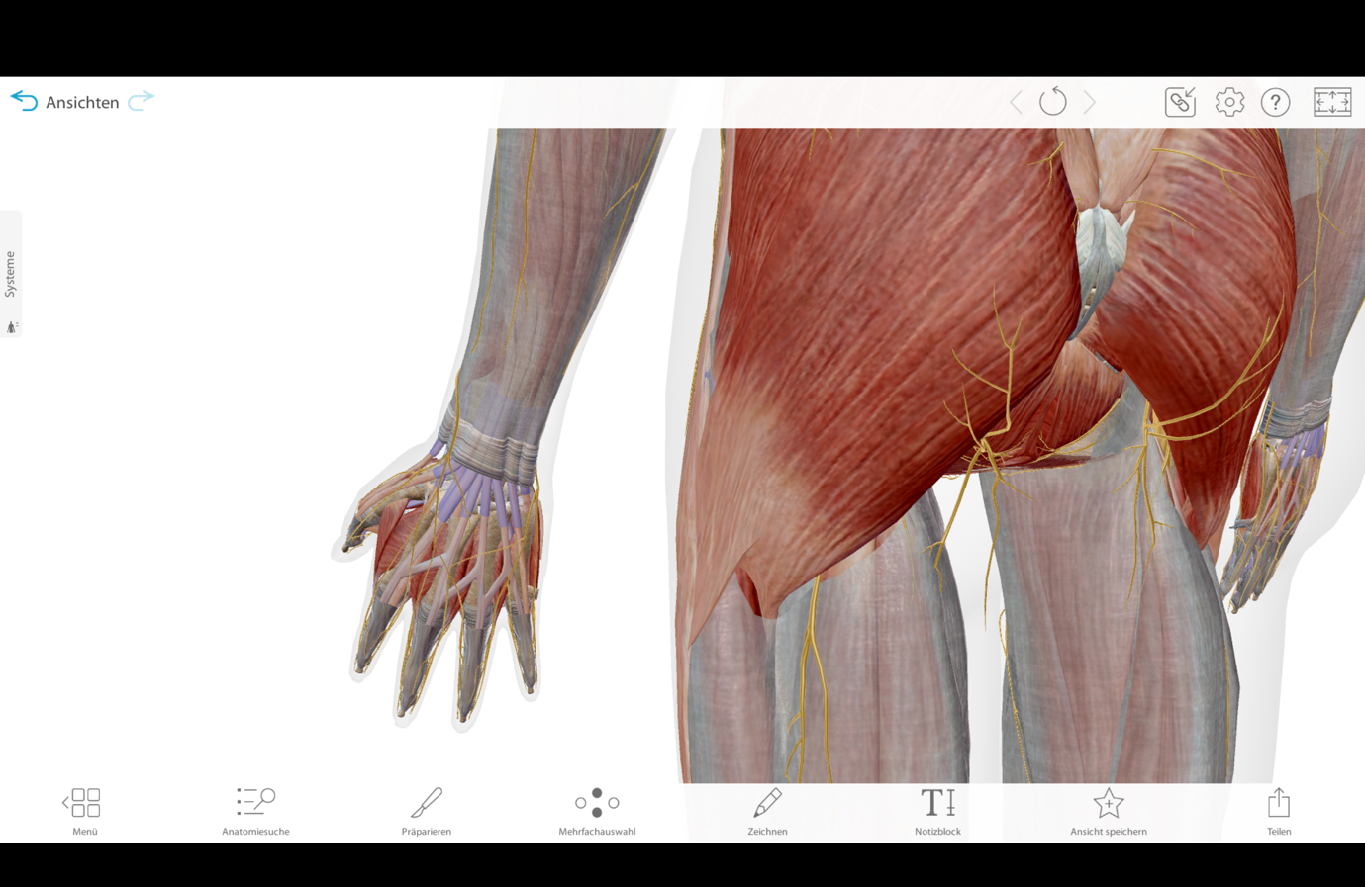

## Head

### Skull (3 markers)

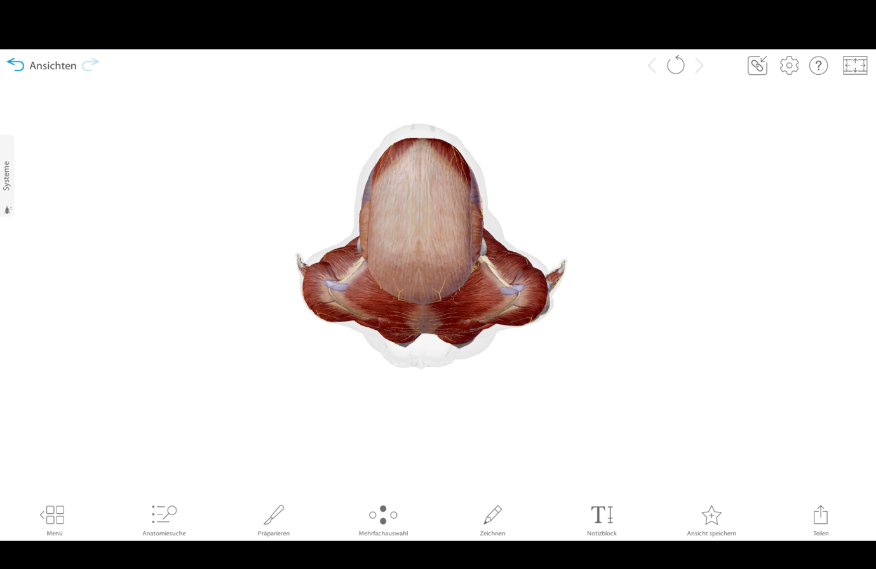

# Measurement process

1.Filling out the consent form.

2.Placing the EMG electrodes.

3.Check if EMGs are not in the way.

4.Placing the markers on the participant.

5.Place markers on the bar.

6.Control if all markers are on the objects.

7. Start with the self-selected warmup.

### Attempts

The systems (VICON, force plates & EMG) need already be set up.

Choosing the weight according to 80% of the 1RM in training for the preferred technique.

Recording:

2 trails for the static pose.  
3 trails with empty bar **and belt** of the preferred technique.

3 trails with 80% of the preferred technique.

3 trails with empty bar **and belt** of the other technique.

3 trails with same absolute weight, as in preferred technique, of the other technique.

3 trails of a squat with the empty bar **and belt**.

**Total: 17 trails**